

Presents

FROGGER
BY: NELSON PEREIRA INC.

DESIGN DOCUMENT
CSE 390

Version 1.2

April 7, 2004

Copyright ©2004 Nelson Pereira Inc. All Rights Reserved.

Table of Contents

I. Design History 3
II. Game Overview 3
a. Introduction 3
b. Tools 3
III. The Game World 4
a. The Road 4
b. The River 4
IV. Game Characters & Elements 4
a. Main Character: Frogger 4
b. Enemies & Hazards 5
c. Elements & Power-Ups 5
V. User Interfaces 6
VI. Rules & Logic of the Game 11
a. Startup of Game 11
b. Gameplay in Motion 11
c. Completing a Level 11
d. Finishing the Game 11
VII. Technical Merit Components 12
a. GUI 12
b. Bitmap Animation 12
c. Vector Rasterization 12
d. Color Effects 12
e. Special Features 12

Design History

VERSION # | DATE | DESCRIPTION
1.0 | 2/20/04 | Initial Draft
1.1 | 3/28/04 | Game in Development, added new changes including characters power-ups and game logic
1.2 | 4/07/04 | Game Implementation Completed, added Technical Merit section

Game Overview

Introduction

The game of Frogger is a one player 2D game in which the player must get Frogger (a frog) from the bottom of the screen to the top without getting hit by the obstacles that are in the way. There is a set time limit to proceed from the bottom of the screen to the top. The screen is divided into 2 halves. The first half is a “road” in which vehicles traverse in a single direction, whether it is right to left or left to right. Once you get to the midway point of the screen, the player has successfully crossed the road. Next, the player must cross a river by “hopping” on logs to get across the river and head “home” which is the top of the screen. Once this point has been reached, the player has completed the level and proceeds to the next level, which is the same interface, but the hazards are now moving quicker. As the player proceeds to each level, the hazards move faster and faster until the player loses all of his lives and the game is over.

Tools

These are the tools that will help with the implementation of the game Frogger:
-Microsoft Visual C++ 6.0
-DirectX 7.0

Note that also DirectX will render all of the graphics in this game.

The Game World

The world of Frogger is divided into 2 halves on the screen, the road and the river. Frogger is the main character and whom the player will control. The basic controls of Frogger are LEFT, RIGHT, UP, DOWN.

The Road

The road consists of 3 rows of vehicles moving in a horizontal fashion. Their speed will vary depending on the level the player is on. Vehicles in this game range in different sizes so in total there are 3 different vehicles in this game.

The River

The river consists also of 3 rows of either crocodiles or logs. In this game, I have decided to only implement the logs and the crocs. Landing safely on the logs ensures that Frogger will not drown. Landing on the crocs is a hazard and thus the player will lose a life. The logs and crocs will be mixed up in each row. The object is to get to the other side of the river to get home and complete the level.

Game Characters & Elements

Characters displayed in this version of this document are finalized

Main Character: Frogger

The main character of this game is Frogger, a frog:



This is the character that the player will control at all times.

Enemies & Hazards

The enemies in Frogger consist of two categories. Road hazards and River enemies.

- Road Hazards

The road hazards in this game are the vehicles that traverse the road. There are 3 different vehicles in this game. They are:

Small Car: 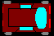 Truck: 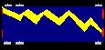 Bus: 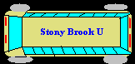

- River Enemies

The river enemies only consist of the crocodiles. There is only one crocodile that will be present in this game, mainly on the 1st and 3rd row of the river. This crocodile enjoys eating frogs for lunch and looks like this:
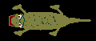

Elements & Power-Ups

Elements in the game that help Frogger include the logs that roll down the river and the sides of the road (see User Interface for the road). Here is what the log looks like:
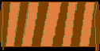

There are 3 power-ups in the game. Each power-up will randomly show on the game screen. Note that since they are randomly placed on the screen, they may at times be unattainable.

- Fly power-up: Adds 25 points to the player’s score.
- Time power-up: Adds 30 seconds to the timer.
- Frog power-up: Adds 1 extra life.

User Interfaces

The game will begin with the Welcome screen:
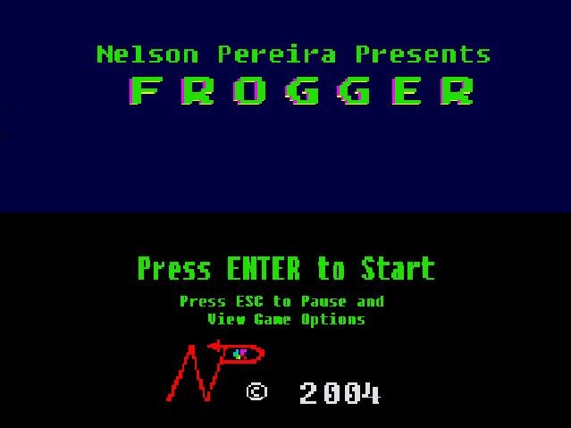

This screen will display some vector rasterization near the center of the screen. A few ‘F’ vectors will move and rotate.

The Game screen contains the road and the river. The Game screen is shown below:
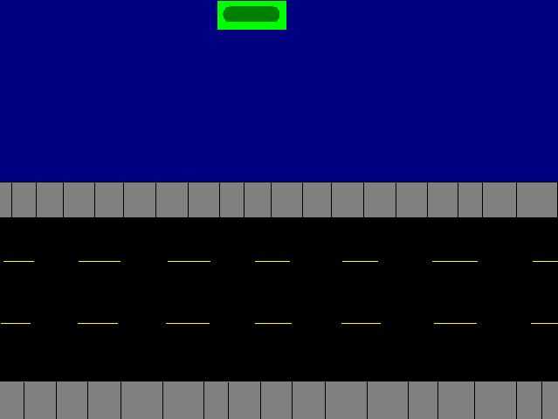

The control of the game is used via the keys LEFT (), RIGHT (), UP (), DOWN (). The gray areas are the sidewalk and the top green area is Home. For visual effects, Home will be flashing in different colors.

When the game is over, a large text will be displayed on the Game screen stating “Game Over”. The player then presses ‘ENTER’ to go back to the Welcome Screen

When the level is completed, a large text will be displayed on the Game screen stating “Level Complete”. The score is shown and the player can then press ‘ENTER’ to move onto the next level.

When a player wants to pause the game, by pressing ‘ESC’ the Pause screen is displayed:

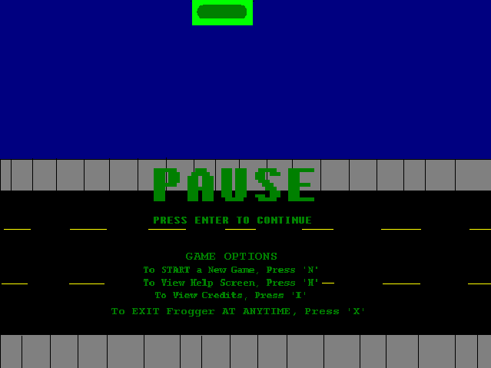

From this screen, the player has the following options. These options except EXIT must be performed in the Pause Screen only:
- New Game: If the player would like to start a new game, pressing ‘N’ key in the Pause Screen will return player to welcome screen to begin a new game
- Help: If the player would like to see the Help Screen or needs help, pressing ‘H’ key in the Pause Screen will show the Help Screen
- Credits (About): If the player would like to see the game credits, pressing ‘I’ key in the Pause Screen will show the Credit Screen.
- Exit: If the player would like to exit the game, pressing ‘X” at any time in the Frogger game will exit the program.

Once the player wants to return to the game, by pressing ‘ENTER’, the player returns to the Game screen.

When a player wants to view the Help screen, the following screen is displayed:

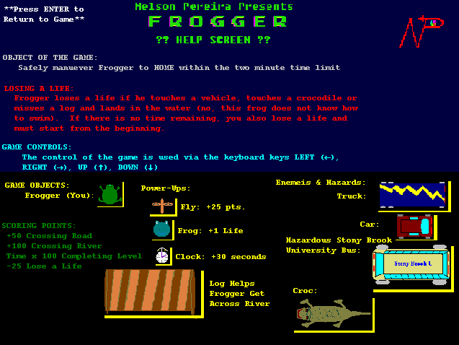

This screen displays all of the rules and logic of the game. When a player has finished viewing this screen, pressing “ENTER” will have the player return to the Game screen.
When a player would like to see the Credits screen, the following screen is displayed:

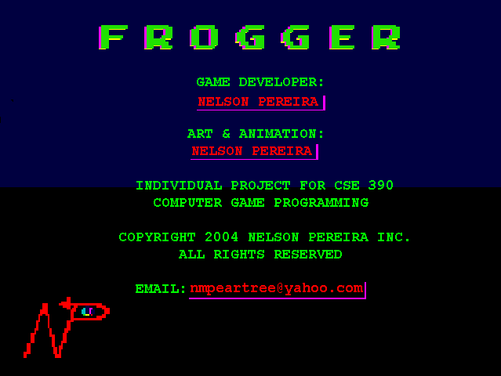
The screen displays the information regarding the Frogger game. When a player has finished viewing this screen, pressing “ENTER” will have the player return to the Game screen

Rules & Logic of the Game

There are a set of rules and logic that this game possesses. The game keeps score, the amount of time remaining and there are a number of lives to begin with. In addition, extra information regarding the explicit definition of a loss of life is explained here in this section.

Startup of Game

The player begins with 6 lives and the timer set to the full amount of 2 minutes to get from one side of the screen to the other. The score is also set to zero.

Gameplay in Motion

Frogger loses a life if he touches a vehicle, touches a crocodile or misses a log and lands in the water (no, this frog does not know how to swim). Once the player losses a life, the level starts over again. If there is no time remaining, a loss of life occurs as well and the player must begin at the start of the level. A loss of life is a deduction of 25 points (-25)

50 Points is awarded for reaching the middle of the level (crossing the road).

When a player obtains a power-up, the rules set by the power-up will execute into play.

Completing a Level

The level is completed once Frogger has reached the top of the screen known as Home. 100 points are awarded for reaching the top of the screen and thus completing the level.
In addition, the time remaining is multiplied by 10 and then added to the current score. The next level is then started with the time reset to 2 minutes.

Finishing the Game

Technically, the game never ends. The game will keep continuing until all lives are lost. As the player continues onto the next level, the speed of the game will increase by a formula. Once the game is over, the game loop ends and the score is taken.

Technical Merit Components

GUI

The following components have been completed

- New Game – by pressing ‘N’ on the Pause screen.
- Pause Game – by pressing ESC on the Game screen
- Continue Game – by pressing ‘ENTER’ on the Pause screen or on the Help screen
- Help – by pressing ‘H’ on the Pause screen
- About – by pressing ‘I’ on the Pause Screen
- Exit – by pressing ‘X’ at anytime
- ESC – does not terminate program, it is used to pause the game

Bitmap Animation

Bitmap animation was used for the following characters:
  - Frogger
  - Crocodile

Vector Rasterization

Vector Rasterization is found mainly on the Welcome Screen and the following has been completed:
- Line Drawing – The 2 lines that set a border around the polygon ‘F’s
- Wireframe Polygon Drawing – The ‘F’ on the center of the Welcome screen
- Solid Filled Polygon Drawing – The two green ‘F’s
- 2D Transformation – used on all vectors on the screen including transformation and rotation
- Collision Detection with Polygons – When the 2 solid filled ‘F’s collide, the wireframe polygon rotates in a different direction

Color Effects

Color effects were used to flash the HOME land on the top of the screen, the headlights and the taillights on all of the vehicles on the road.

Special Features

All of the bitmaps are originally constructed by the author making the game more original.

Cheats have been added for more gameplay. All cheats are activated by pressing a button in the Credits Screen and text will briefly display stating that the cheat has been activated. They can be used more than once.
- Life Cheat – press F2 , adds 1000 lives
- Infinite Time Cheat – press F4, timer does not countdown
- Swimming Cheat – press F10, Frogger can cross through the water without the use of logs
- Super Slow Cheat – press F12, all objects move super slow

